**Project Development Phase**

**Sprint-4**

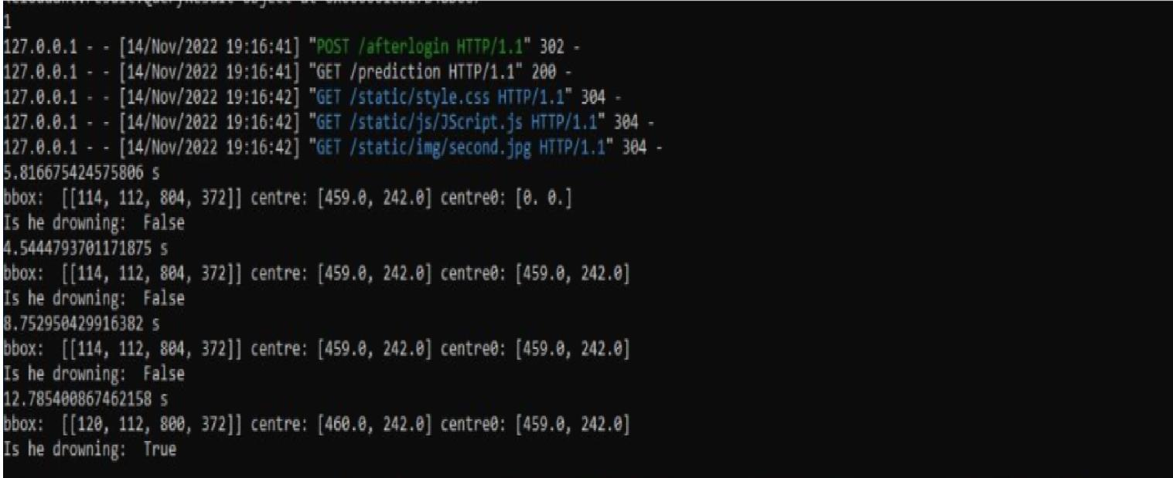**Run the Application and Output**

|  |  |
| --- | --- |
| DATE | 18 NOV 2022 |
| TEAM ID | PNT2022TMID27630 |
| PROJECT NAME | Virtual Eye - LifeGuard For Swimming Pools  To Detect |
| MAXIMUM MARKS | 8 MARKS |

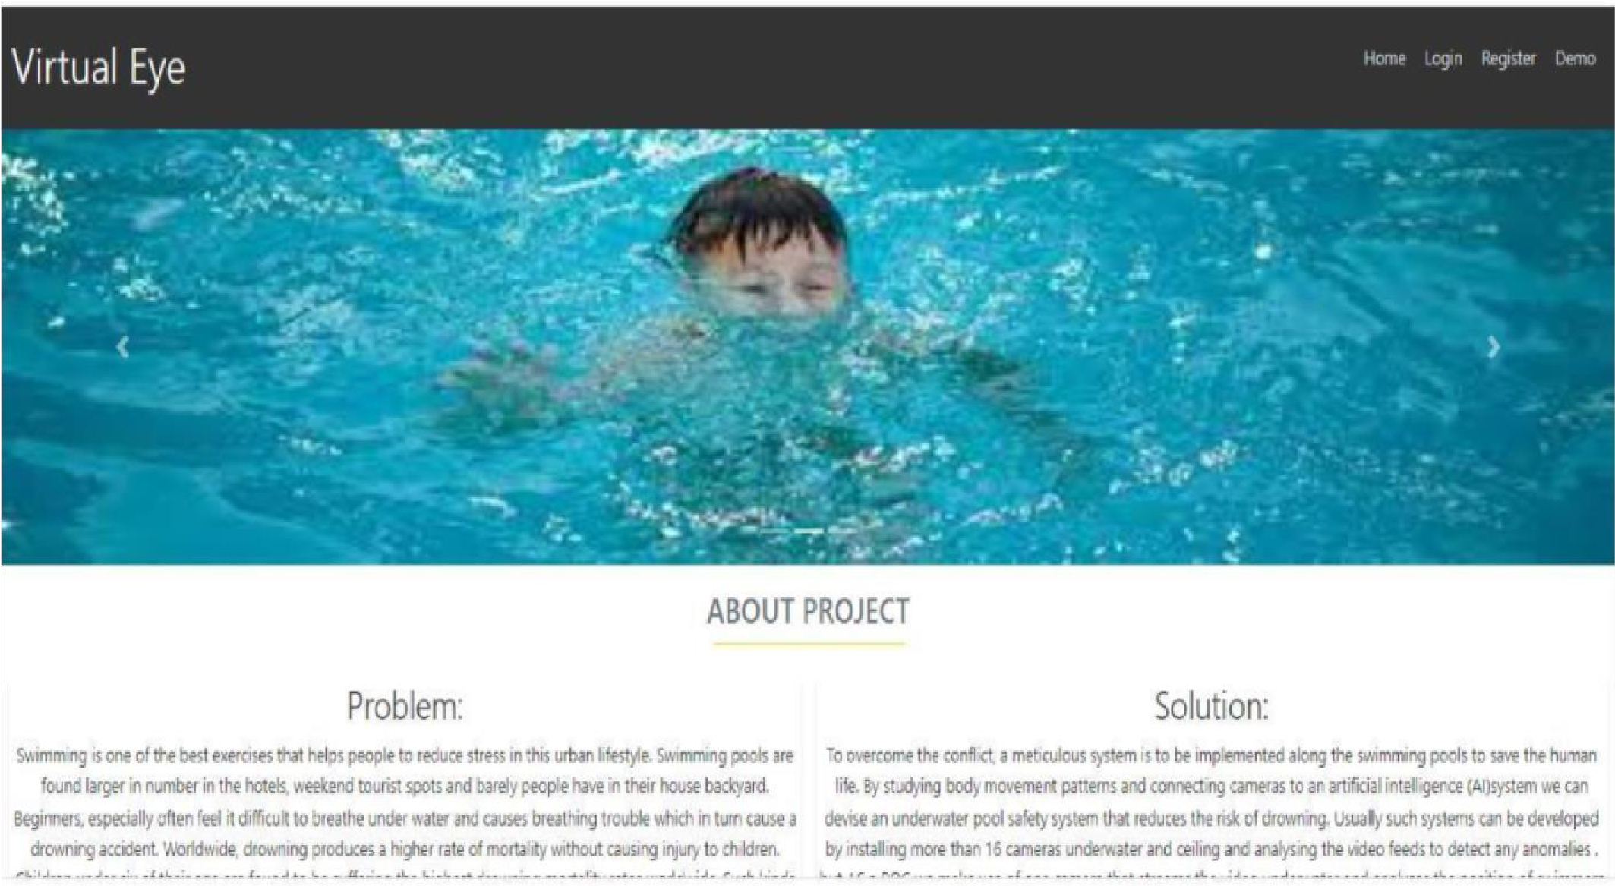 **Run the Application and Output:**

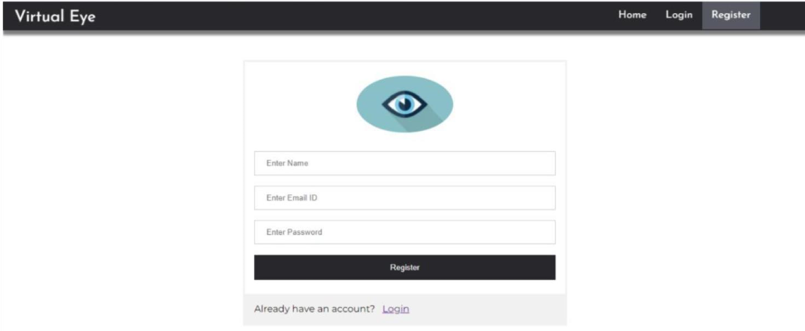**Register in the website**

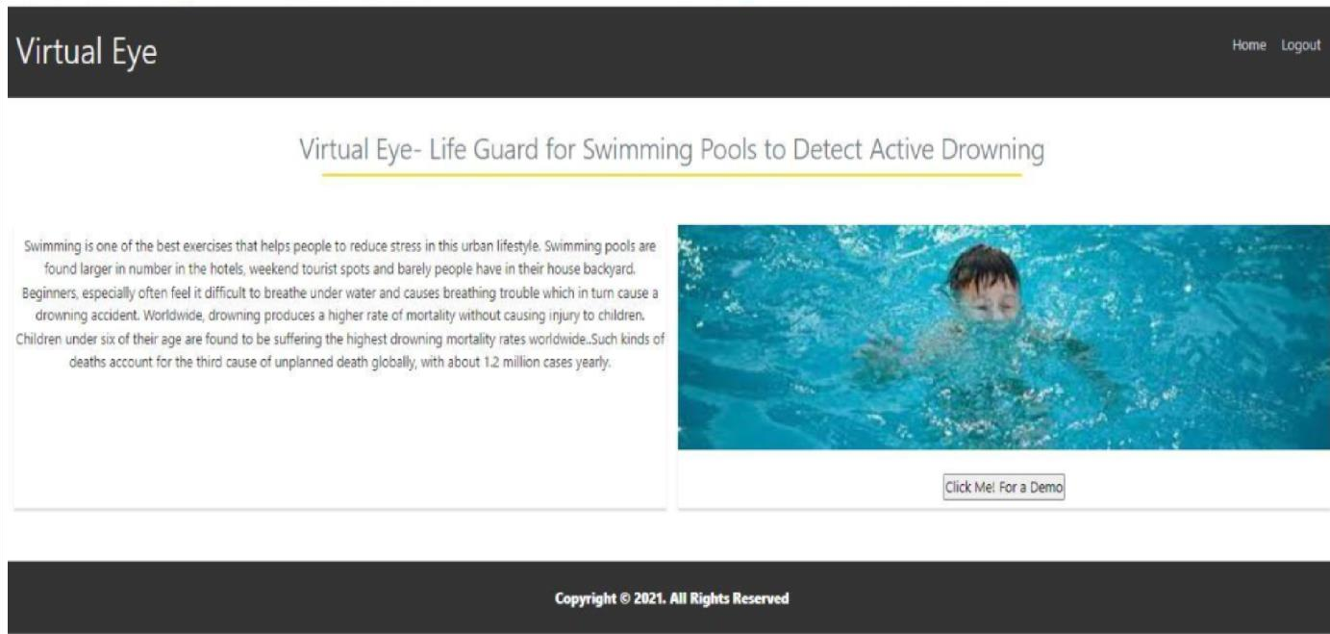**Login with your Credential**

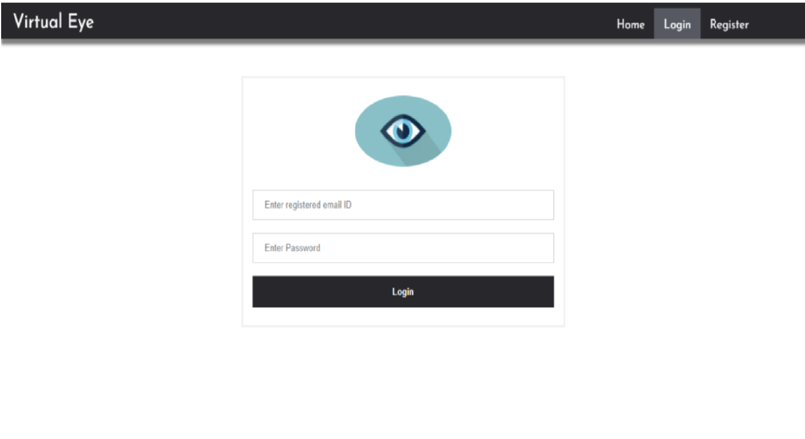

**After Login**

**Output**

